📘 AGENCY CRM – DEVELOPMENT BLUEPRINT
Version: 1.0
Backend: Spring Boot
Frontend: React (Vite)
Database: MySQL
Authentication: JWT + Role-Based Access Control

1️ SYSTEM OVERVIEW

1.1 Purpose
Agency CRM is a web-based system designed to manage:
- Leads
- Employee hierarchy
- Client conversion
- Plan management
- Performance dashboards
The system supports structured role-based access and hierarchical tracking.

2️ SYSTEM ARCHITECTURE
React (Frontend)
⬇ REST API
Spring Boot (Backend)
⬇
MySQL Database

3️ DATABASE DESIGN (MySQL)

3.1 Tables Overview
- users
- leads
- clients
- plans

3.2 USERS TABLE
Field | Type
id | BIGINT (PK, AUTO_INCREMENT)
name | VARCHAR(100)
email | VARCHAR(100), UNIQUE
password | VARCHAR(255)
role | ENUM('ADMIN','MANAGER','TEAM_LEAD','EMPLOYEE')
manager_id | BIGINT (FK, nullable)
team_lead_id | BIGINT (FK, nullable)
created_at | TIMESTAMP
Hierarchy Logic:
- Manager reports to Admin
- Team Lead reports to Manager
- Employee reports to Team Lead

3.3 LEADS TABLE
Field | Type
id | BIGINT (PK, AUTO_INCREMENT)
name | VARCHAR(100)
email | VARCHAR(100)
phone | VARCHAR(20)
source | VARCHAR(100)
interested_percentage | INT
status | ENUM('NEW','CONTACTED','INTERESTED','CONVERTED','LOST')
assigned_to | BIGINT (FK → users.id)
created_at | TIMESTAMP
updated_at | TIMESTAMP

3.4 CLIENTS TABLE
Field | Type
id | BIGINT (PK, AUTO_INCREMENT)
name | VARCHAR(100)
email | VARCHAR(100)
phone | VARCHAR(20)
plan_id | BIGINT (FK → plans.id)
assigned_employee | BIGINT (FK → users.id)
conversion_date | TIMESTAMP

3.5 PLANS TABLE
Field | Type
id | BIGINT (PK, AUTO_INCREMENT)
name | VARCHAR(100)
description | TEXT
price | DECIMAL(10,2)
created_at | TIMESTAMP

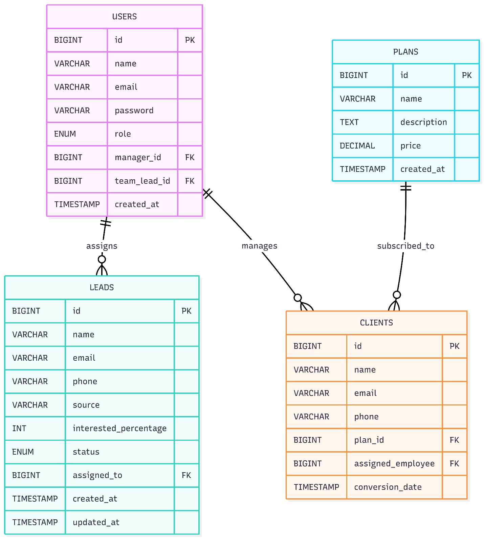

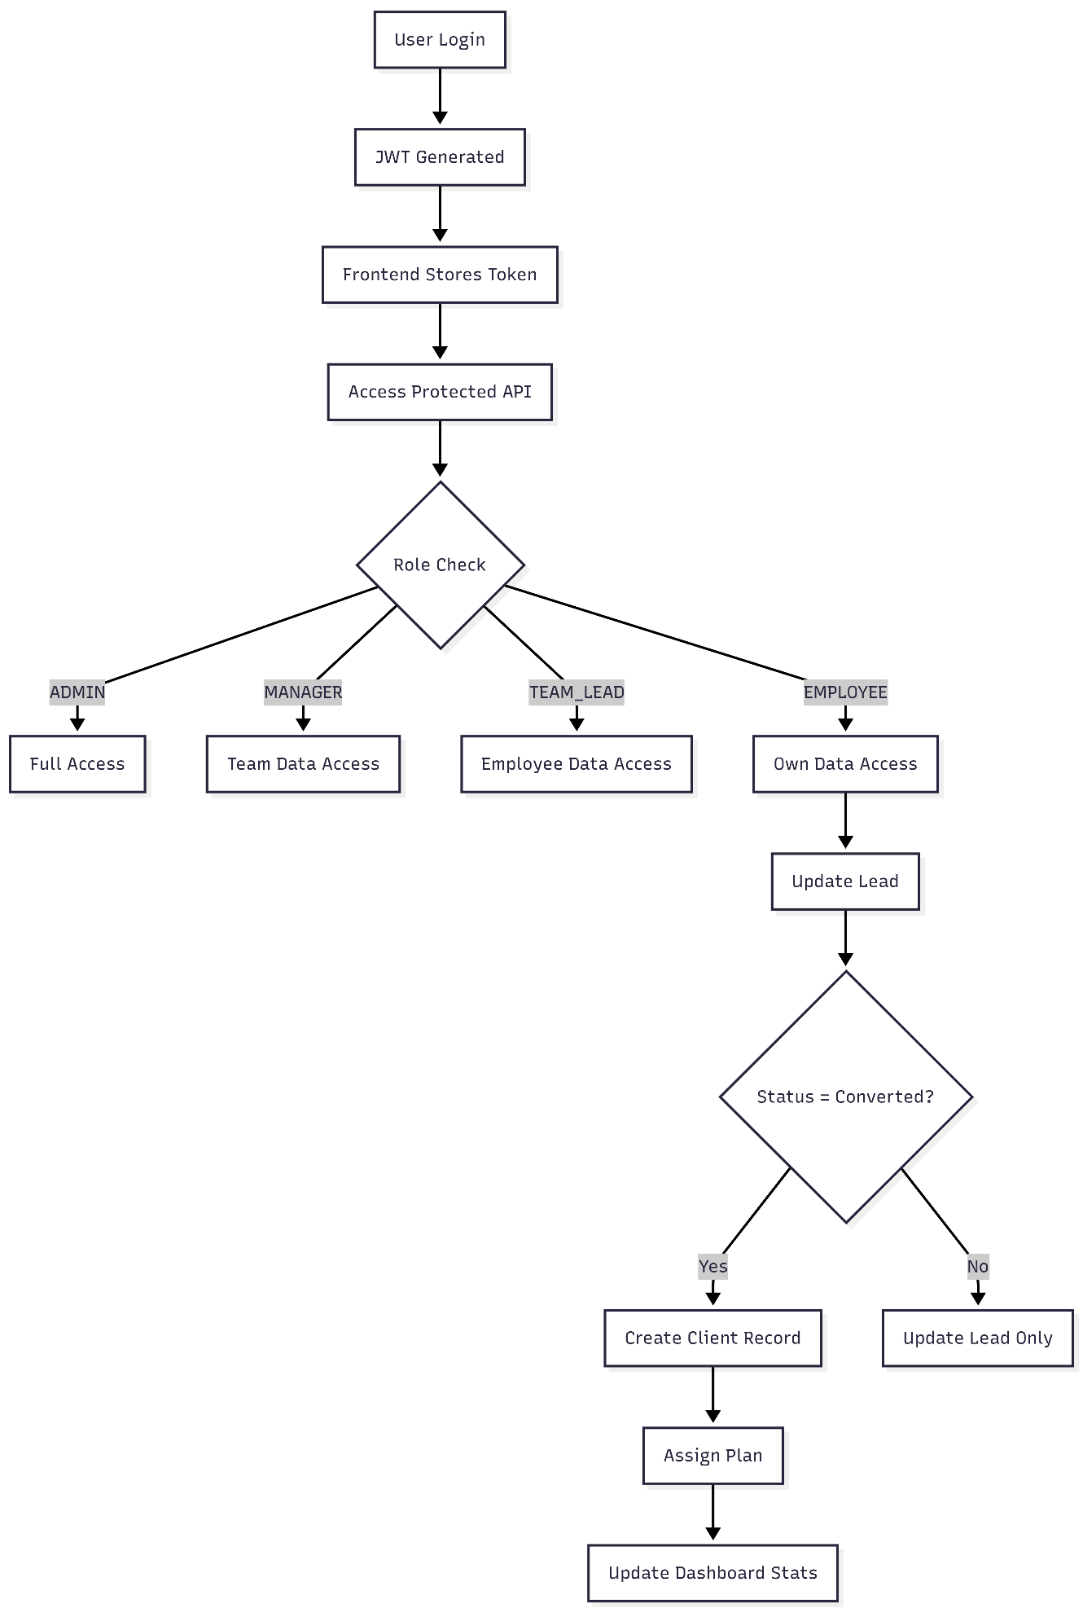

4️ BACKEND PROJECT STRUCTURE
com.agencycrm
│
├── config
│ └── SecurityConfig
│
├── controller
│ ├── AuthController
│ ├── LeadController
│ ├── ClientController
│ ├── PlanController
│ └── DashboardController
│
├── service
│ ├── AuthService
│ ├── LeadService
│ ├── ClientService
│ ├── PlanService
│ └── DashboardService
│
├── repository
│ ├── UserRepository
│ ├── LeadRepository
│ ├── ClientRepository
│ └── PlanRepository
│
├── entity
│ ├── User
│ ├── Lead
│ ├── Client
│ └── Plan
│
├── dto
│
├── security
│ ├── JwtFilter
│ ├── JwtUtil
│ └── CustomUserDetailsService
│
└── exception

5️ AUTHENTICATION FLOW
- User sends email + password
- Backend validates credentials
- JWT token generated
- Token returned to frontend
- Frontend sends token in header
Header Format:
Authorization: Bearer
Spring Security:
- Stateless session
- JWT filter before UsernamePasswordAuthenticationFilter

6️ ROLE-BASED ACCESS FLOW
Access Control Rules:
ADMIN
- Access all endpoints
MANAGER
- Access users under them
- Access leads and clients under their team
TEAM_LEAD
- Access employees under them
- Access assigned team leads
EMPLOYEE
- Access only assigned leads and clients
Filtering logic implemented in Service layer.

7️ CORE BUSINESS FLOW

7.1 Lead Creation Flow
- Admin / Manager / Team Lead creates lead
- Lead assigned to employee
- Lead stored in database

7.2 Lead Update Flow
Employee updates:
- Interested percentage
- Status
Status progression:
NEW → CONTACTED → INTERESTED → CONVERTED / LOST

7.3 Lead Conversion Flow
When status = CONVERTED:
- Create Client record
- Copy basic details
- Assign plan
- Store conversion date

7.4 Plan Creation Flow
Admin:
- Creates plan
- Plan stored in database
- Plan selectable during client conversion

8️ DASHBOARD DATA FLOW
Dashboard data is calculated using aggregation queries.

8.1 Employee Dashboard
- Total Leads Assigned
- Interested Leads
- Converted Leads
- Conversion Rate

8.2 Team Lead Dashboard
- Total Team Leads
- Team Conversions
- Team Conversion Rate
- Employee-wise stats

8.3 Manager Dashboard
- Total Leads Under Manager
- Total Clients
- Team Performance Breakdown

8.4 Admin Dashboard
- Total Leads
- Total Clients
- Total Users
- Plan Distribution
- Overall Conversion Rate

9️ API STRUCTURE

Authentication
POST /api/auth/login
POST /api/auth/register

Leads
POST /api/leads
GET /api/leads
GET /api/leads/{id}
PUT /api/leads/{id}
DELETE /api/leads/{id}
PUT /api/leads/{id}/convert

Clients
GET /api/clients
GET /api/clients/{id}
PUT /api/clients/{id}
DELETE /api/clients/{id}

Plans
POST /api/plans
GET /api/plans
PUT /api/plans/{id}
DELETE /api/plans/{id}

Dashboard
GET /api/dashboard/admin
GET /api/dashboard/manager
GET /api/dashboard/teamlead
GET /api/dashboard/employee

10. DEVELOPMENT EXECUTION ORDER
- Create Spring Boot project
- Configure MySQL connection
- Create Entities
- Create Repositories
- Implement JWT authentication
- Implement role-based security
- Build Lead module
- Implement conversion logic
- Build Client module
- Build Plan module
- Implement Dashboard aggregation queries
- Connect React frontend

